COAL – Lab 6 – Lab tasks

Task 1:
INCLUDE Irvine32.inc

.data
msg byte "enter a number:", 0
num dword 0
equals byte " = ", 0
multiply byte " * ", 0

.code
main PROC
mov edx, offset msg
call writestring
call readint
mov num, eax
mov ecx, 10
mov esi, 1

table:
mov eax, num
call writedec
mov edx, offset multiply
call writestring
mov eax, esi
call writedec
mov edx, offset equals
call writestring
mov eax, num
mul esi
inc esi
call writedec
call crlf
loop table

main ENDP
END main
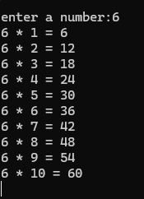

Task 2:

INCLUDE Irvine32.inc

.data
msgIn BYTE "Enter a number: ",0
msgOut BYTE "Factorial = ",0
n DWORD 0
result DWORD 1

.code
main PROC
mov edx, OFFSET msgIn
call WriteString
call ReadInt
mov n, eax

mov ecx, eax
mov eax, 1

fact_loop:
mul ecx
loop fact_loop

mov edx, OFFSET msgOut
call WriteString
call WriteDec
call Crlf
call ReadChar

exit

main ENDP
END main

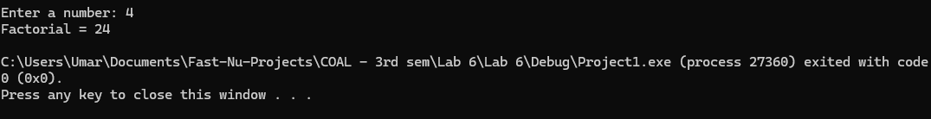

Task 3:

INCLUDE Irvine32.inc

.data
a DWORD 5
b DWORD 5
msg1 BYTE "a < b",0
msg2 BYTE "a = b",0
msg3 BYTE "a > b",0

.code
main PROC
mov eax, a
mov ebx, b
cmp eax, ebx
call DumpRegs

mov eax, 3
mov ebx, 7
cmp eax, ebx
call DumpRegs

mov eax, 9
mov ebx, 2
cmp eax, ebx
call DumpRegs

exit
main ENDP
END main

